CYCLES OF DISADVANTAGE
poverty, education, inequalities and social exclusion

A contribution to the European Year 2010

MADO auditorium, 20 May 2010, 14.30-17.30

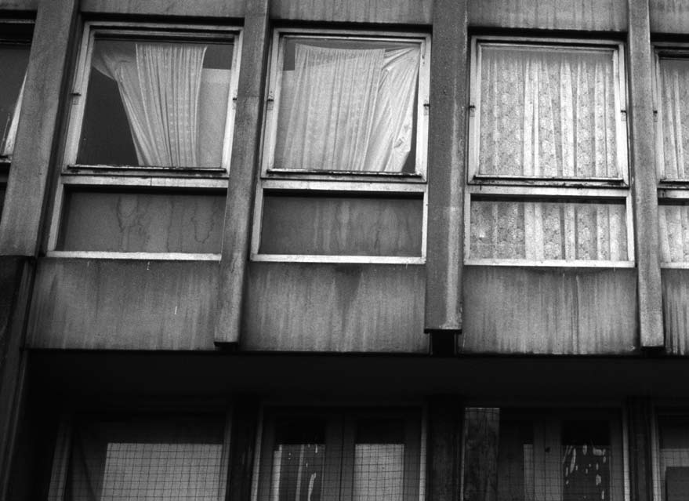
80 million people in Europe live below the poverty line; 19 million of them are children. Children and young people in poverty face greatly reduced educational prospects and future life chances.

Despite the general presumption that education and training systems offer opportunities for individual upward social mobility and inclusion, decades of research show that the opposite is often true - that education and training often make things worse. Evidence suggests that all EU education and training systems themselves are to a greater or lesser extent marked by inequalities (in access to high quality education, in treatment and in educational outcomes) which reflect, reproduce and very often compound the effects of socio-economic disadvantage.

- How does poverty and disadvantage affect people's educational opportunities and learning experiences at different stages in life and at different levels of the education system?

- How do learning experiences affect economic and social outcomes, life chances and social mobility?

- Where are the inequalities in the education system and what are their consequences? How exactly do they work to reproduce or compound disadvantage?

With professor Andy Green


Andy Green is Professor of Comparative Social Science at the University of London Institute of Education and Director of the ESRC Research Centre on Learning and Life Chances in Knowledge Economies and Societies (LLAKES). He specialises in the comparative (historical and sociological) analysis of education and training systems. He has published widely on a range of education issues, with major works translated into Chinese, German, Japanese and Spanish. He has provided research and consultancy for a variety of national and international bodies including CEDEFOP, OECD, UNESCO and the European Commission. For more information see: http://www.ioe.ac.uk/study/LCEN_11.html



DG Education & Culture

